**Project Name : Designing a Resume/CV Using Canva.**

**Introduction**

**1.1 Overview**

Through this project we the team members created a Resume/CV of our own by using Canva.

**1.2 Purpose**

For the job purpose we need to create a resume of our own.

**2.Problem Definition & Design Thinking**

**2.1 Empathy Map**

We had some trouble while gathering information on the Empathy Map.

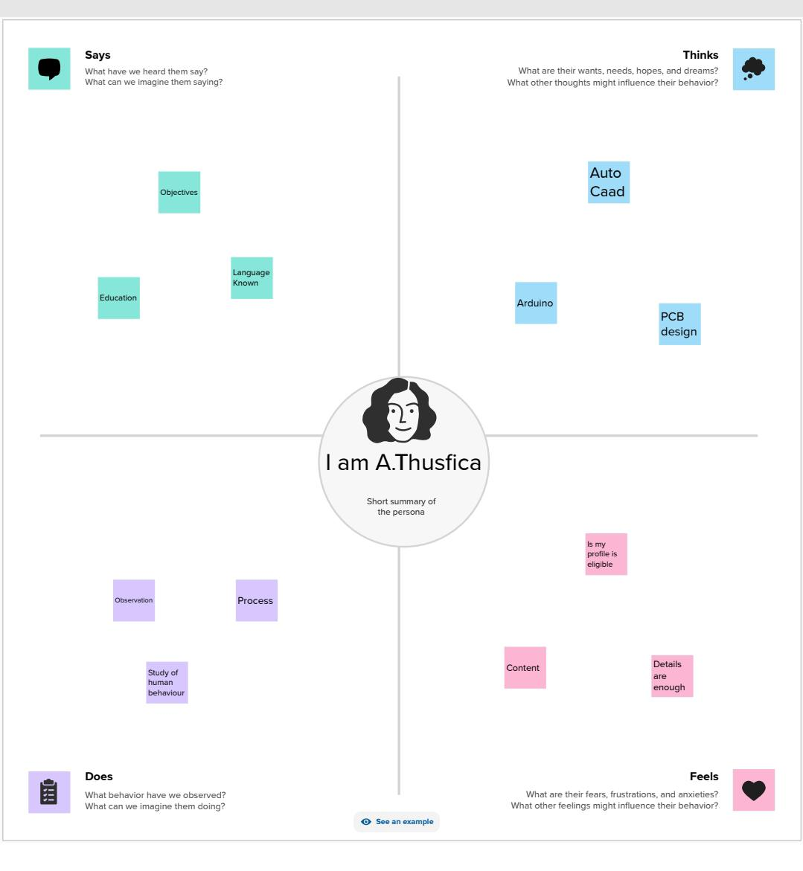

**2.2 Ideation & Brainstorming Map**

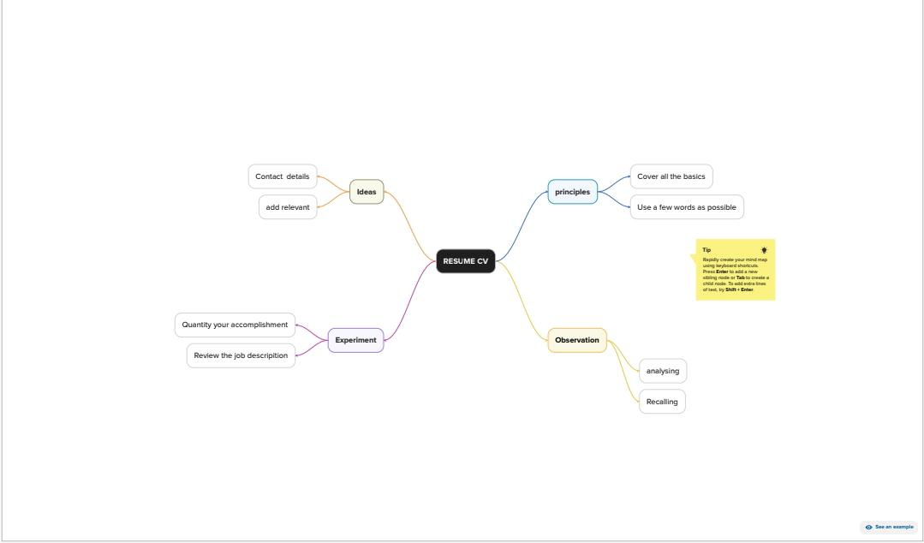

**3.Result**

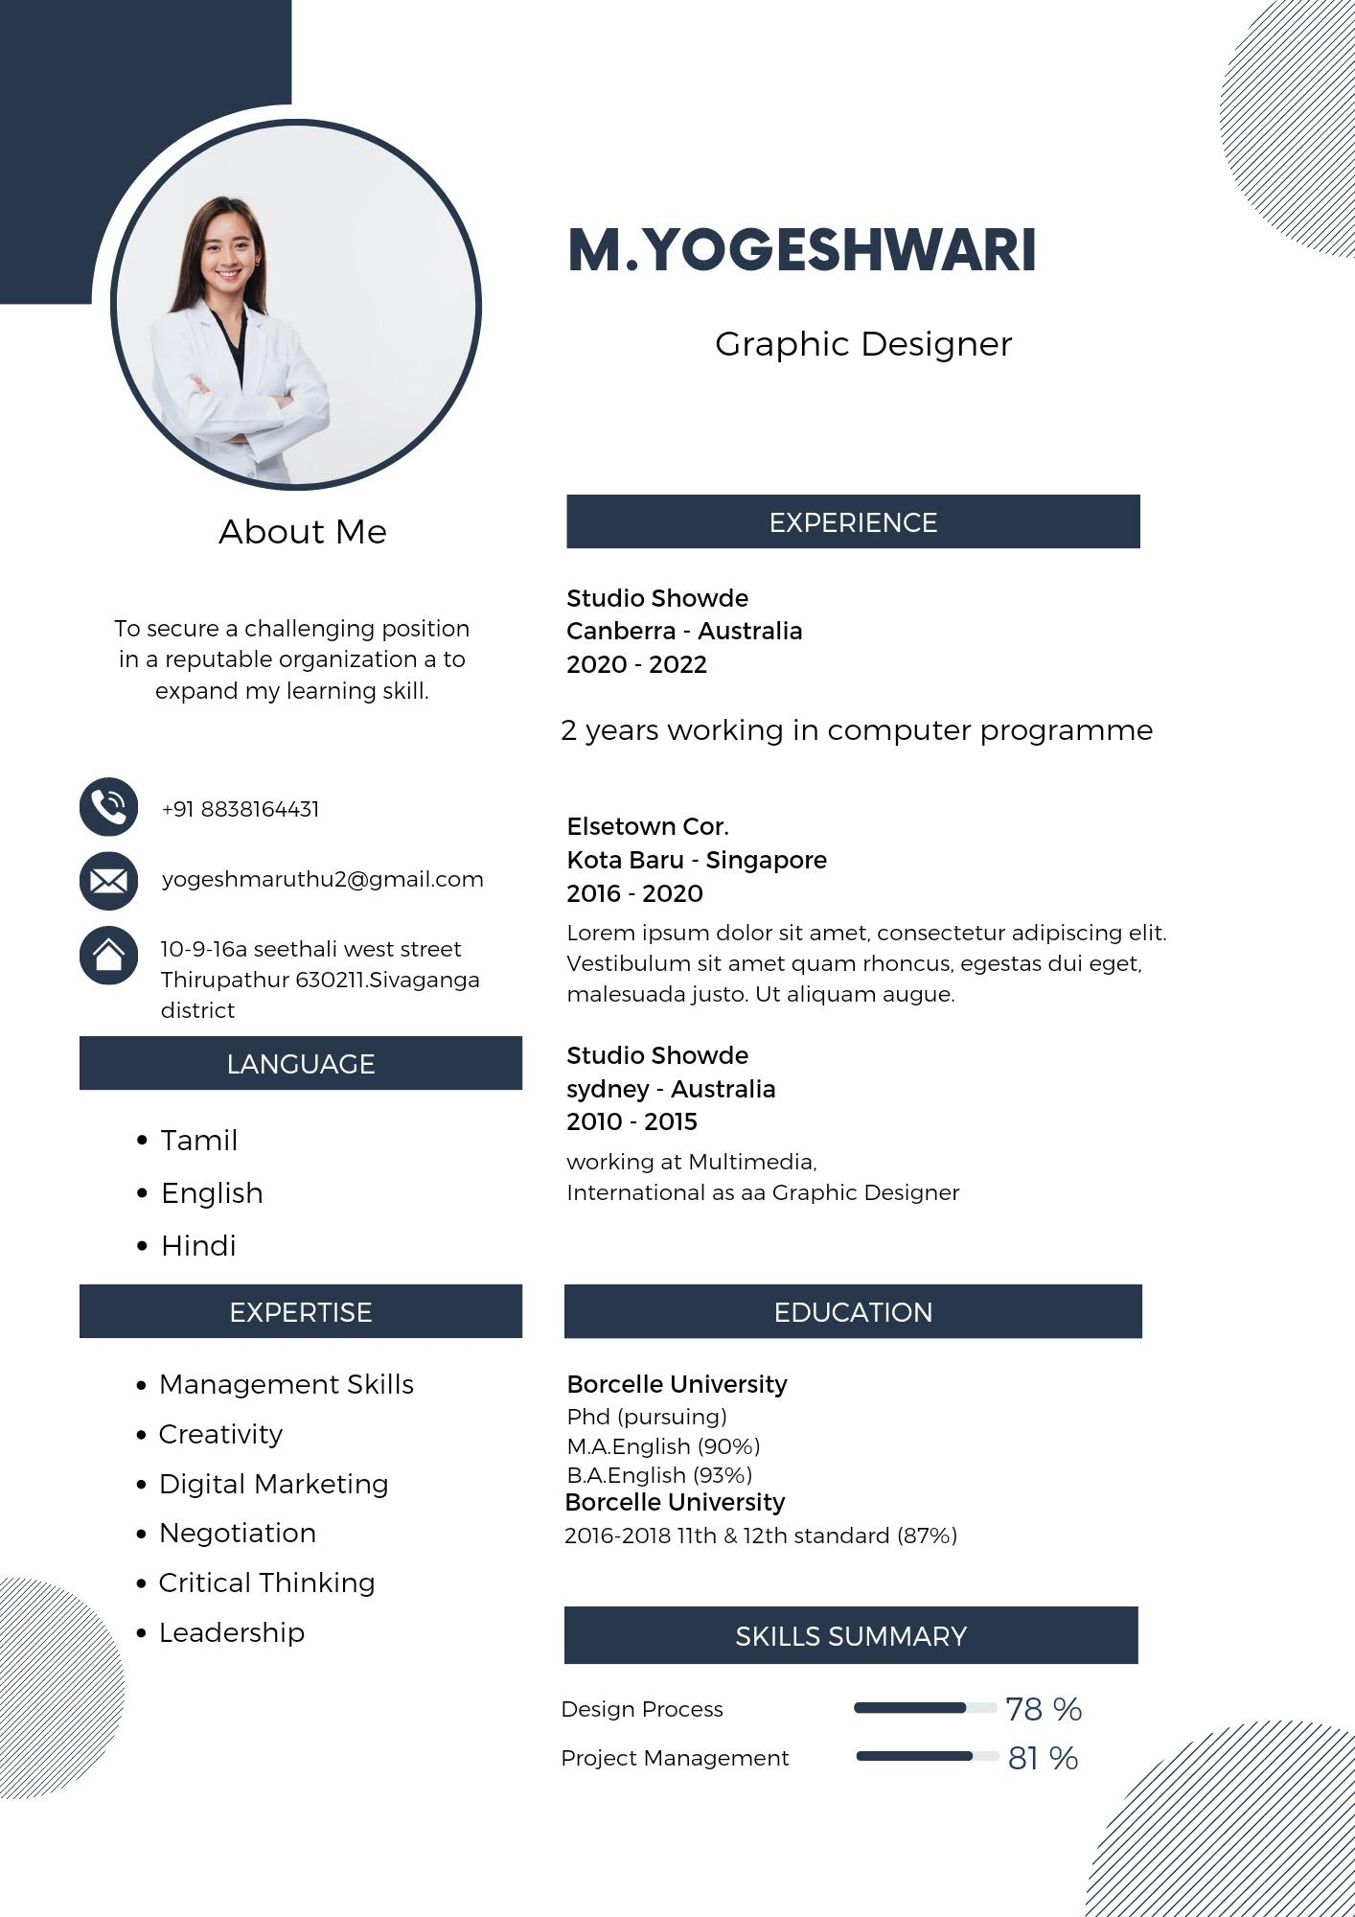

**4.Advantage & Disadvantages**

Advantage: we learn to create the resume of our own.

Disadvantage: nothing

**5.Application**

We may apply this designing skill in future wherever is needed.

**6.Conclusion**

We learn a lot of new things about Editing and how to make certificate it is really useful.